TTA Existing Student Registration for the Calendar Year 2020-2021.
STEP 1: Please use this URL : https://www.catamilacademy.org/cta/StudentReg.aspx for registering the existing TTA Student.
STEP 2: Select the ‘Yes’ radio button and click ‘Continue’ button.
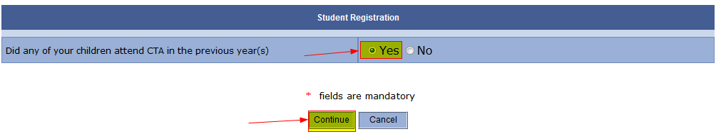
STEP 3: Please use your parent email id and password that you have been using in the last year to check your Kid(s) progress and click ‘Continue’ Button.
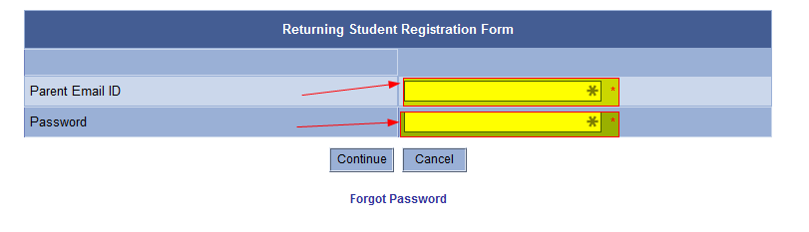STEP 4: Select the student name from “Select Student” drop down list
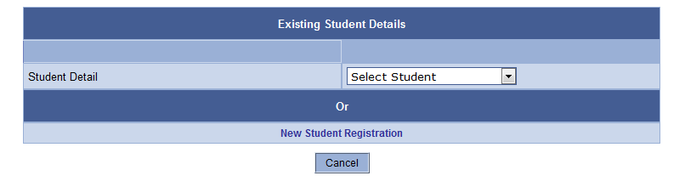

STEP 5: Please enter appropriate information on all the highlighted fields as all the other fields would be auto populated from the last year information that you have provided,
STEP 5.1: If your “Public School City” is not available in “Select City” drop down list, please select “Others” and enter your School City in the text box next to “Others (City)”.
STEP 5.2: If your “Public School Name” is not available in “Select School” drop down list, please select “Others” and enter your School Name in the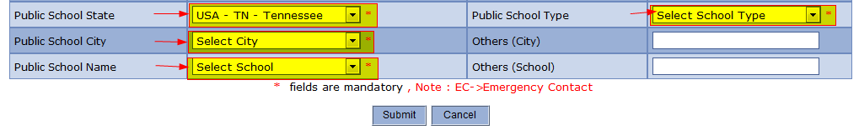 text box next to “Others (School)”.

STEP 5.3: Click “Submit” Button.
STEP 6: Please click “OK” Button.
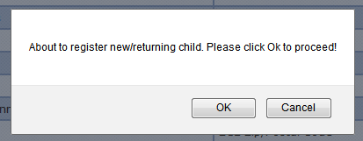

STEP 7: Please select atleast one of the Volunteer Help options as indicated and Click on “Submit” button. 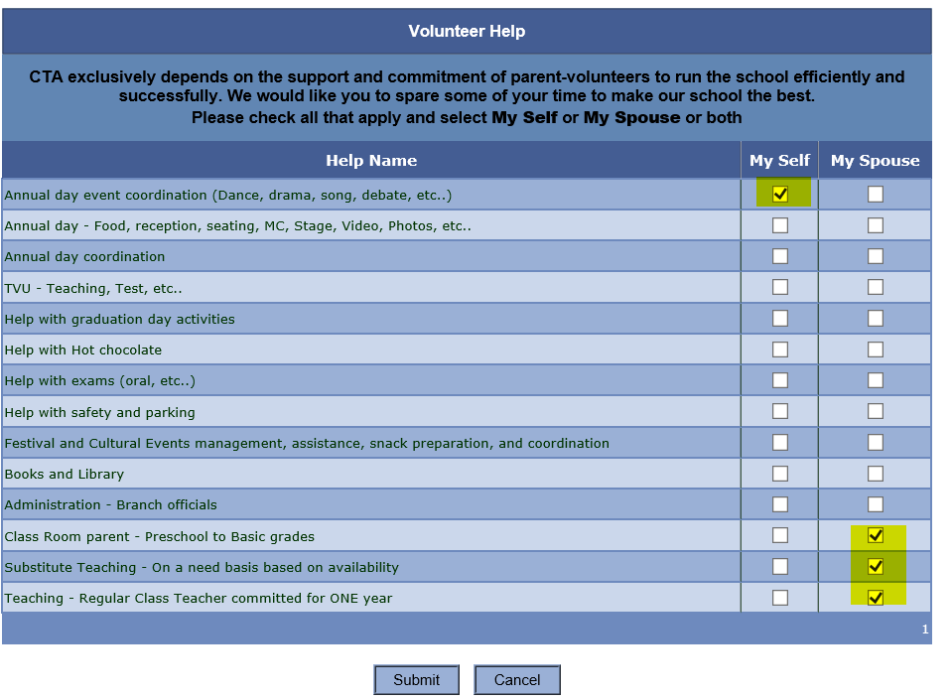

STEP 8: Please scroll down and enter Parent/Guardian’s Full Legal Name and Click “I Agree” Button.
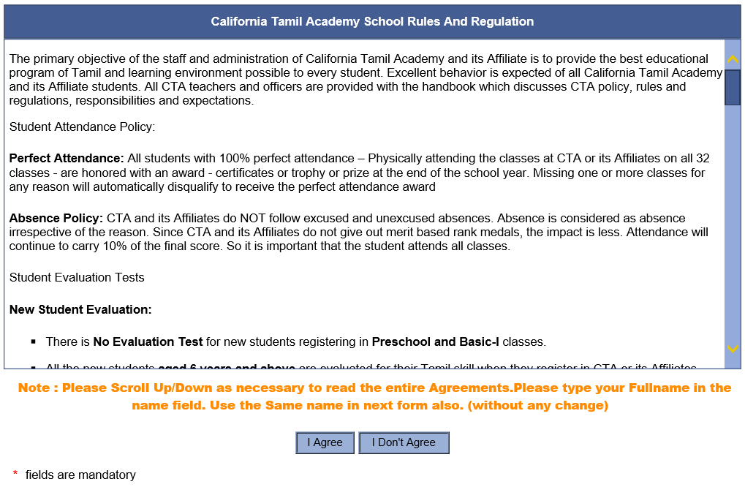
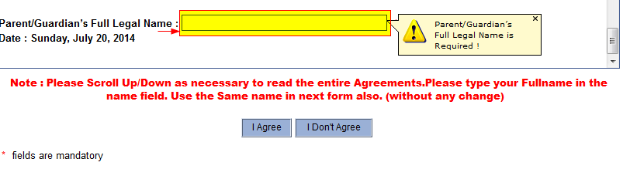

STEP 9: Please enter Parent/Guardian’s Full Legal Name in the HighLighted text field and and Click “I Agree” Button.
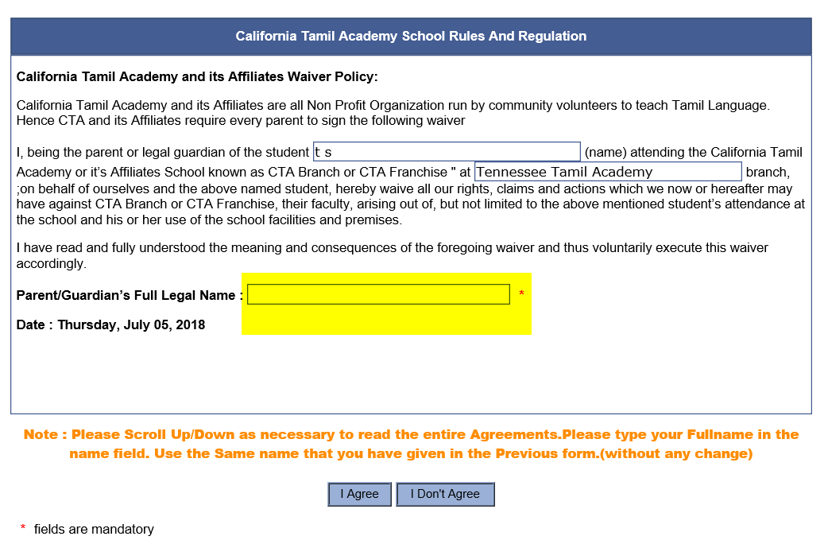
STEP 10: Please click on “Submit” Button.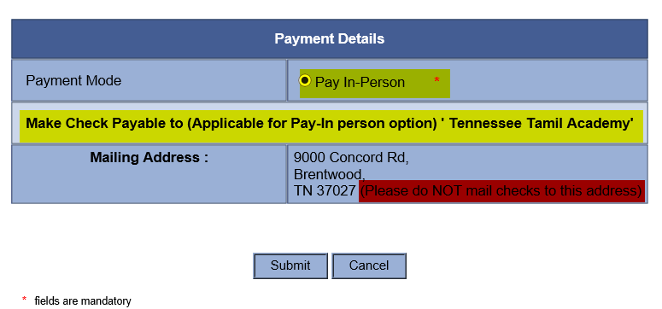
NOTE: Please do not mail your checks to the Mailing Address, we accept the Checks payable to “Tennessee Tamil Academy” for $250/Year (Two Hundred and Fifty Only) in the First Day of School on August 14th, 2020.
STEP 11: Click on “Print” to get your registration Confirmation form printed for your reference. If you need to register one more student please repeat the steps from STEP 1 to STEP 11.
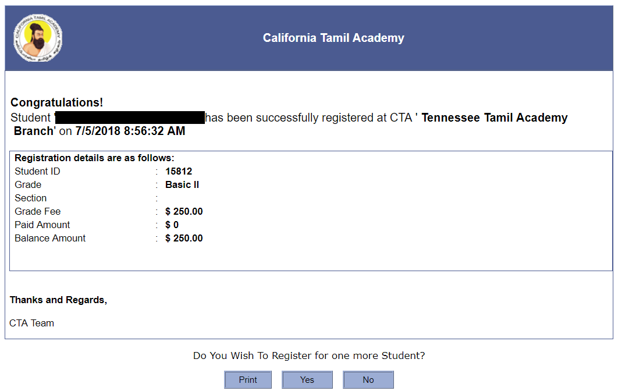
STEP 12: Please check your email inbox that you have provided while registering the Student. You should have received an email from ita.admin@itamilacademy.org for the New Student Registration confirmation.
NOTE: If the email is not in your inbox please check your email account’s spam folder.

